WebSocketSDK Sample for Win7
Updated March 30, 2018

System Requirements
Item | Supported | Tested
OS | Win 7 / Windows Server 2008 | Win7
IIS | IIS 7 / IIS 7.5 | IIS7.5
ASP.NET | 4.0 | 4.0
Internet Explorer | IE10, IE11 | IE11
Visual Studio | 2010 / 2012 / 2013 | VS2013
M50 FW | v2.2.6 20151027 or Later | v2.2.9

Preparing Device

Set Active Client Mode
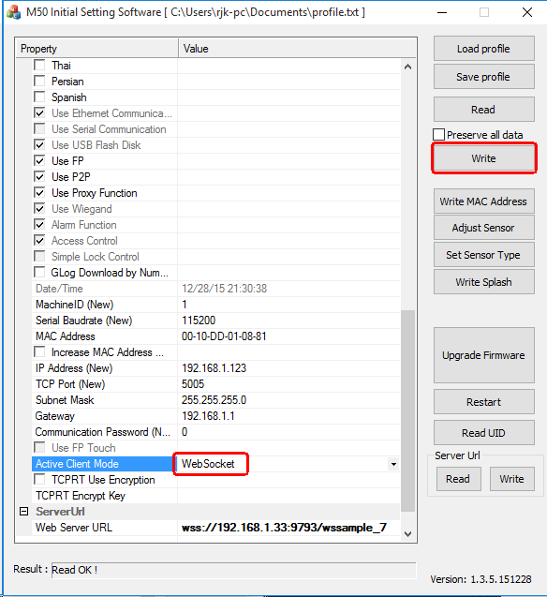

Set Device Serial Number
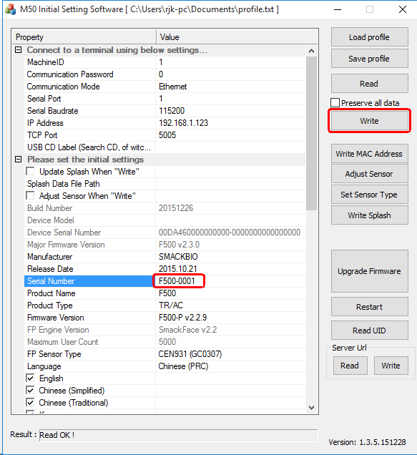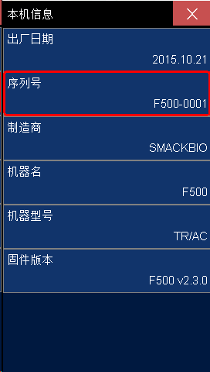

Set WebServer Address
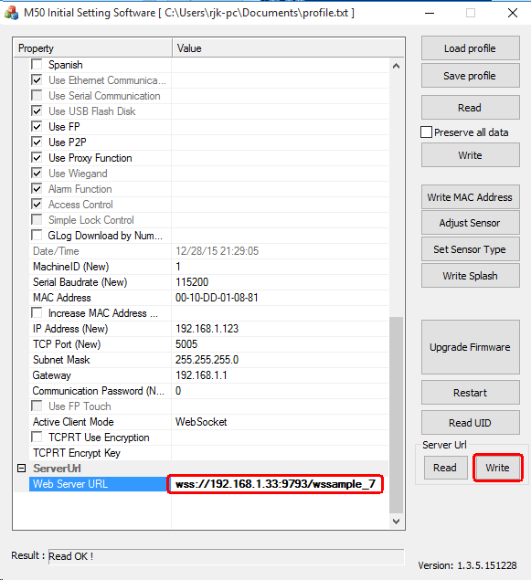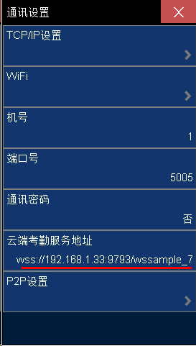

Restart the device

Configuring IIS
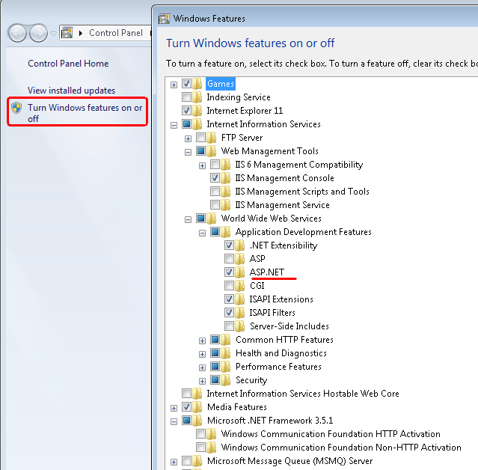
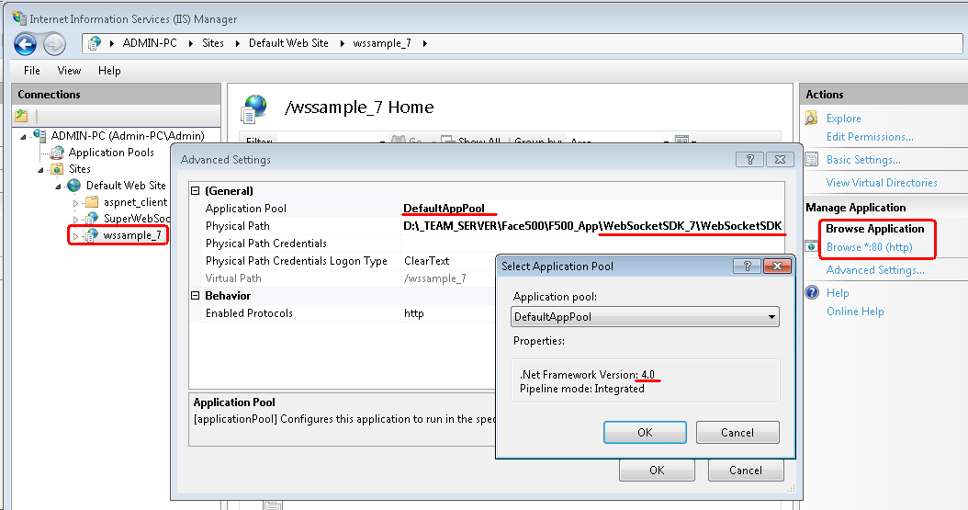
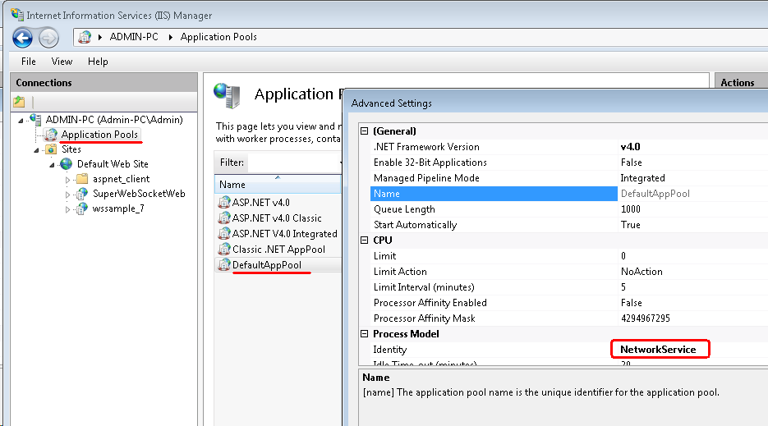

Configuring and Running WebSocketSDK Sample Application
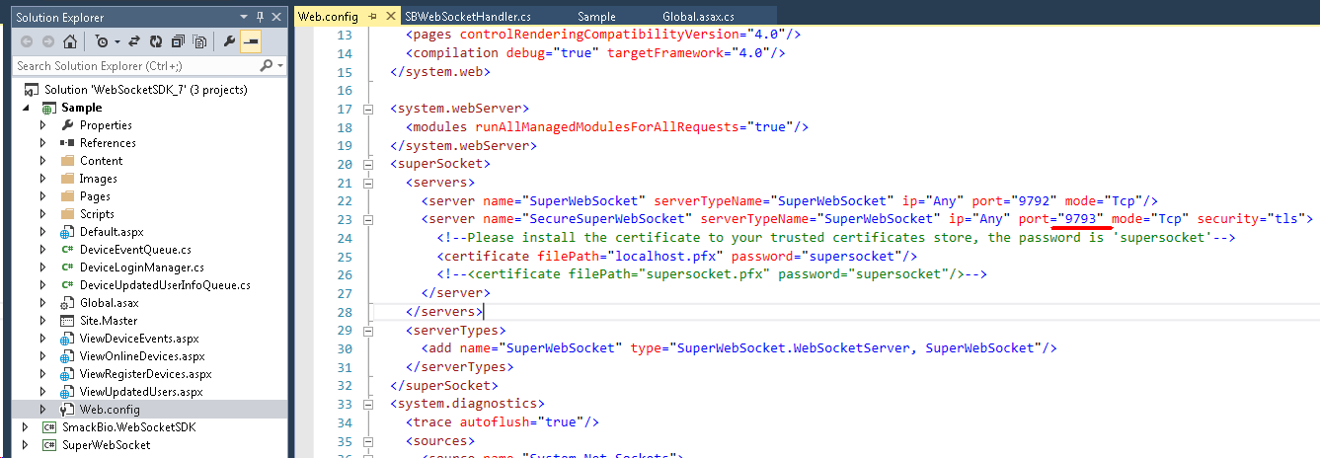
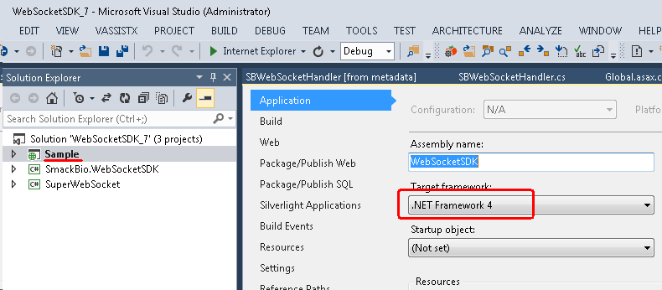
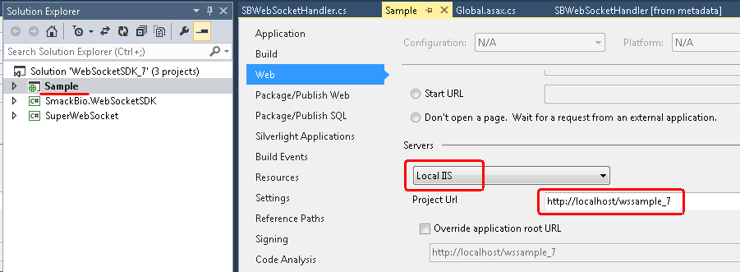
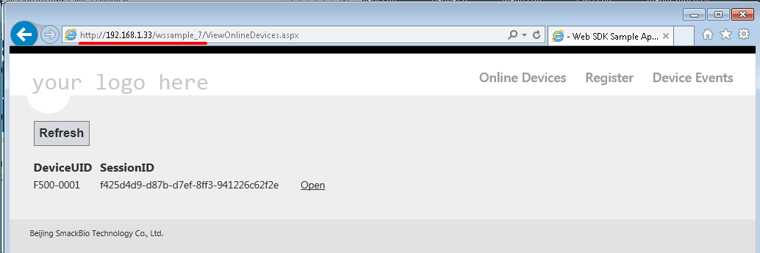

Publishing Web Site
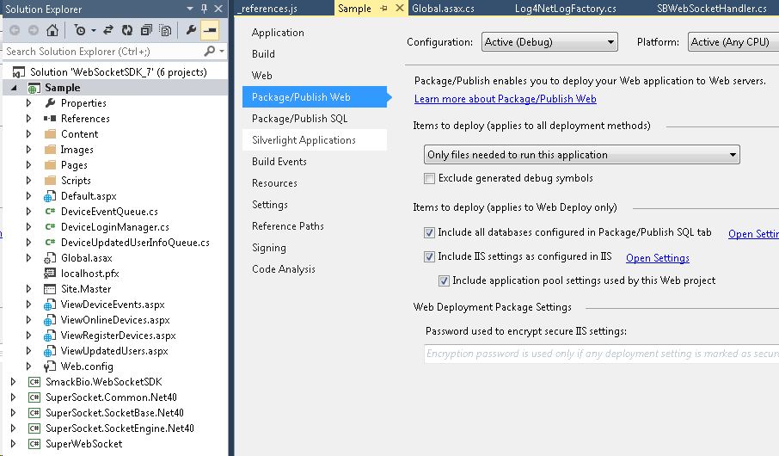
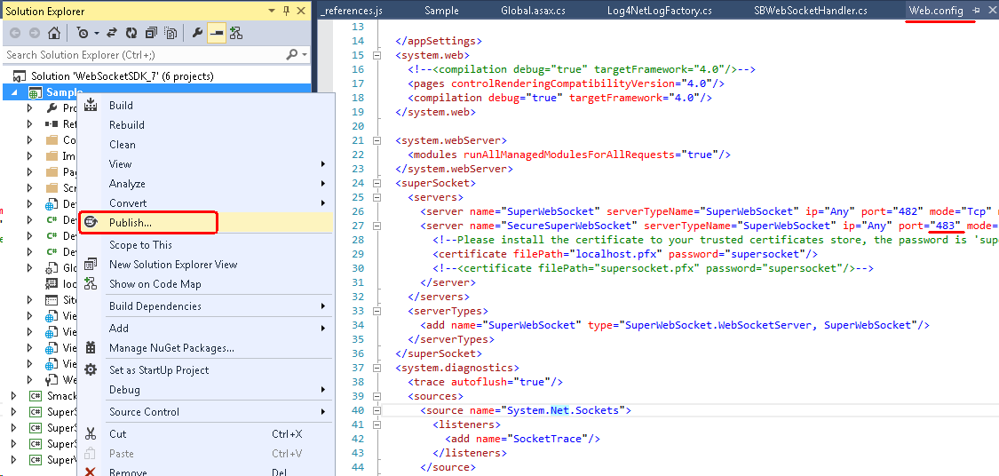
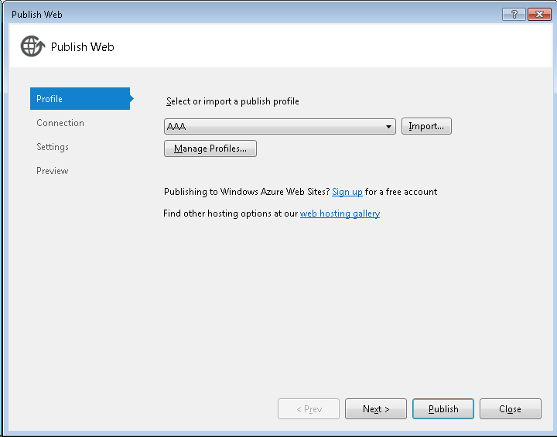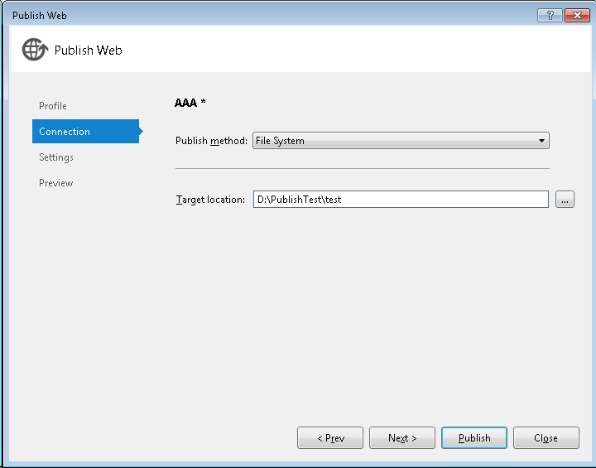

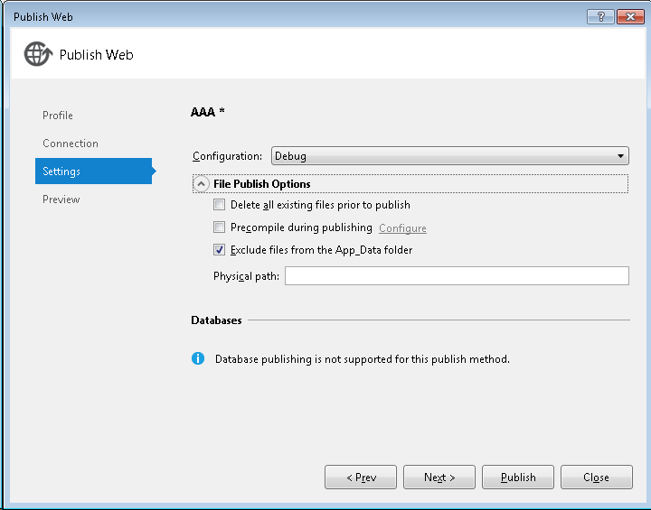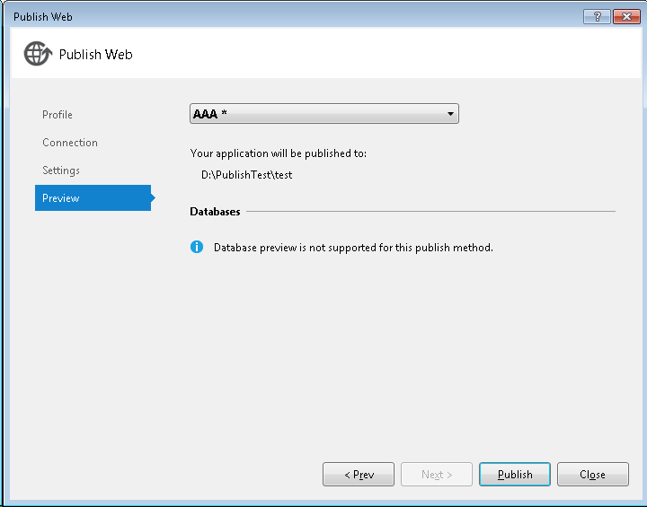
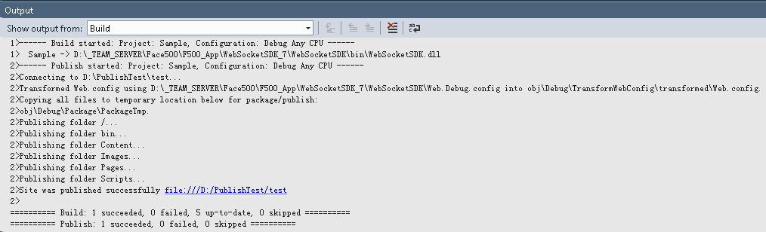
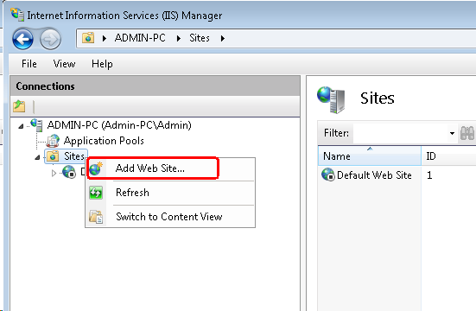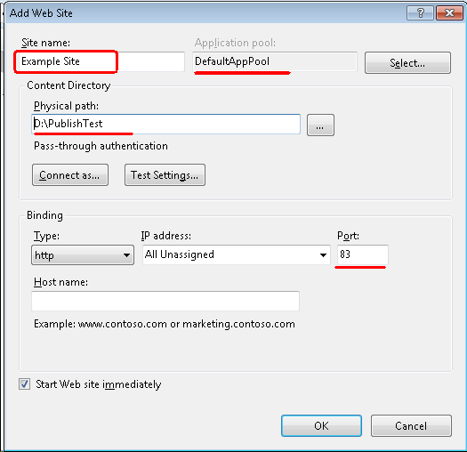
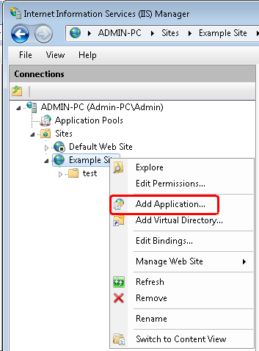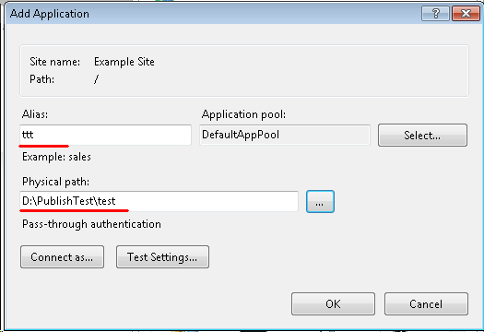
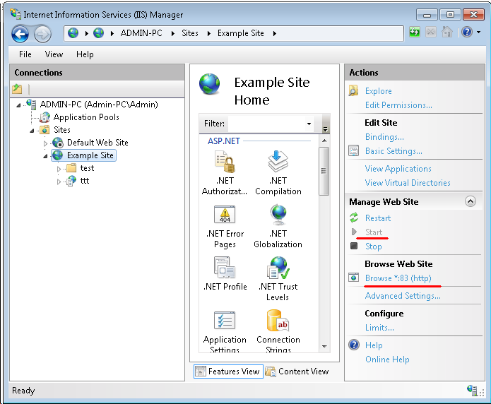
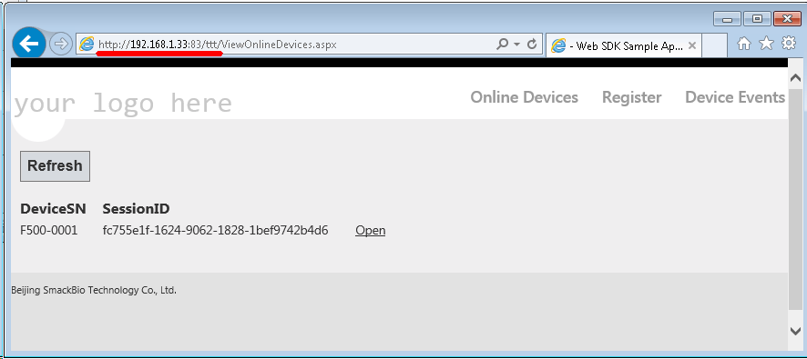

Troubleshooting

Enabling logs
If the application does not work as expected, you can enable logging and analyze the log.
To enable log, Edit “log4net.config” (located in “Sample” project) as shown below.
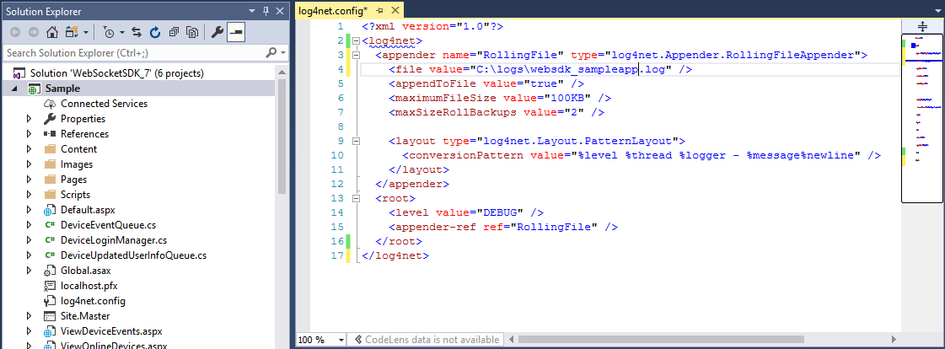
This is path to the log file.
After publishing the web site and restarting IIS, you should be able to see logs generated by sample application.
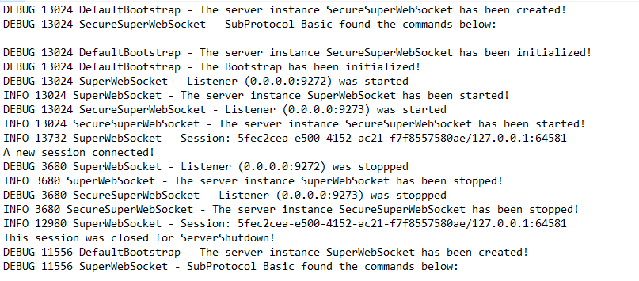

Running web site gives error: “This configuration section cannot be used at this path.”
You may face this issue when you run the sample application on an IIS server. The error looks like following:
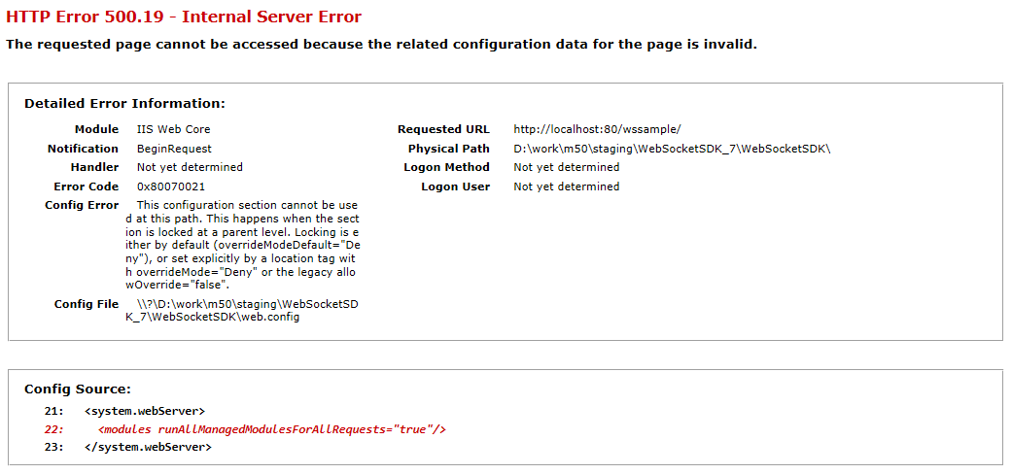
Cause of the problem: This error happens when you deploy the sample application as a child of existing web site, and the parent site has locked some configuration sections.
How to fix: In IIS management console, open Configuration Editor of parent web site, and unlock the sections.
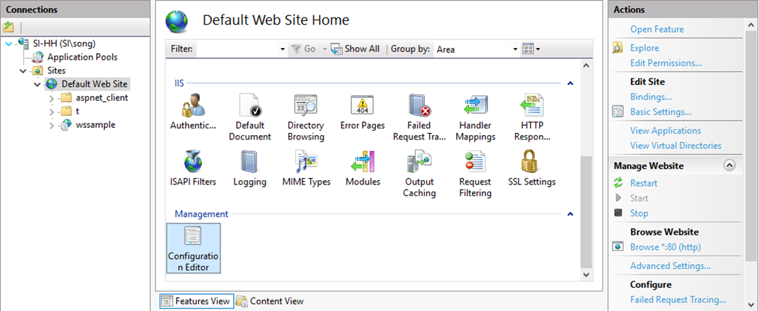
This is the parent site; you need to edit configuration for this site.
This is the site where sample application is deployed.
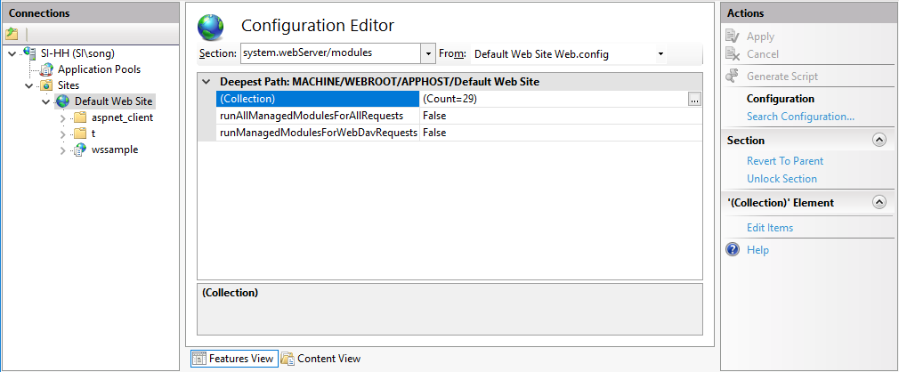
Select the locked configuration section here. You can find which section is locked in the IIS detailed error page.
Click this to unlock configuration section.

